**1> PROJECT TITLE:=**

**BLOOD BANK MANAGEMENT SYSTEM**

**2> PROJECT DESCRIPTION:=**

This web based project is based on interaction between acceptor, donor and organization for blood providing to needy. The acceptor are someone who want blood . The donor are donating blood to an associated organization. The organization deals as mediator between acceptor and donors .They all interconnected with some functionalities and are authenticated using username and password. The admin has all the rights to insert, update and delete new or existing donors, acceptors or organization .The blood details can also be modified by admin and is used for mapping with other users.

**3> MAIN MODULES :=**

* ADMIN
* ACCEPTOR
* DONOR
* ORGANIZATION

**4> MAIN MODULES INTERNAL CHARACTERSTICS :=**

* ADMIN
* Manage Donor
* Manage Acceptor
* Manage Blood Type
* Manage Organization
* Logout
* ACCEPTOR
* View Acceptor Details
* Search Blood
* Search Organization
* Change Password
* Logout
* DONOR
* View Donor Details
* Give Blood
* Change Password
* Logout
* ORGANIZATION
* View Organization Details
* Search A Donor
* Blood Stock
* Logout

**5> ROLES/FUNCTIONS OF MAIN MODULES:=**

1. ADMIN
2. Manage Donor – In this “Add New Donor” , ”Modify Donor” ,”Delete Donor” , “View Donor ” , “Back To Admin Dashboard” will be present .
3. Manage Acceptor -In this “Add New Acceptor” , ”Modify Acceptor” ,”Delete Acceptor” , “View Acceptor” , “Back To Admin Dashboard” will be present.
4. Manage Blood Type – In this “Add New Blood Type”, ”Modify Blood Type” , “Delete Blood Type” , “View Blood Type ” , ”Back to Admin Dashboard ” will be present.
5. Manage Organization – “ Add New Organization ”, “ Modify Organization ” ,” Delete Organization ” , “ View Organization ”,” Back to Admin Dashboard” will be present.
6. Logout **-** By this we can end the current session of the current user and will resume to Welcome Page.
7. ACCEPTOR
8. View Acceptor Details – Here display all fields which was filled by acceptor during registration time.
9. Search Blood – Here acceptor will search blood type and will get all the details of donor donating blood with searched blood type .This will lead interaction between acceptor and donor.
10. Search Organization – Here acceptor by selecting blood type will search the for organization which are available with it and display all the organization details .
11. Change Password - Here Acceptor can change his current password to new password and with some validation rules.
12. Logout **-** By this we can end the current session of the current user and will resume to Welcome Page.
13. DONOR
14. View Donor Details - Here display all fields which was filled by donor during registration time.
15. Give Blood – Donor will select Blood Type, enter Quantity that is to be donated and associated organization name .
16. Change Password - Here Acceptor can change his current password to new password and with some validation rules.
17. Logout **-** By this we can end the current session of the current user and will resume to Welcome Page.
18. ORGANIZATION
19. View Organization Details - Here display all fields which was filled by organization during registration time.
20. Search A Donor – Here organization will be search for all donor details available with the required blood type .
21. Blood Stock - This will display quantity of blood and its type available.
22. Logout **-** By this we can end the current session of the current user and will resume to Welcome Page.

**6> TABLES AND ITS ATTRIBUTES**

There are 6 tables in total including users table also.

1. **USERS TABLE : -** This table consists all the id ,username and password of donor, admin ,acceptor, Organization with its datatypes and its field length.

|  |  |  |  |  |
| --- | --- | --- | --- | --- |
| **Sr no** | **Field Name** | **Field Type** | **Field Length** | **Additional Details** |
| 1 | ad_id | Int | 20 | AUTOINCREMENT  PRIMARY KEY  NOT NULL |
| 2 | Ac_id | Int | 20 | AUTOINCREMENT  PRIMARY KEY  NOT NULL |
| 3 | Do_id | Int | 20 | AUTOINCREMENT  PRIMARY KEY  NOT NULL |
| 4 | Org_id | Int | 20 | AUTOINCREMENT  PRIMARY KEY  NOT NULL |
| 5 | Ad_username | Varchar2 | 120 | NOT NULL |
| 6 | Ac_username | Varchar2 | 120 | NOT NULL |
| 7 | Do_username | Varchar2 | 120 | NOT NULL |
| 8 | Org_username | Varchar2 | 120 | NOT NULL |
| 9 | Ad_password | Varchar2 | 120 | NOT NULL |
| 10 | Ac_password | Varchar2 | 120 | NOT NULL |
| 11 | Do_password | Varchar2 | 120 | NOT NULL |
| 12 | Org_password | Varchar2 | 120 | NOT NULL |
| 13 | User_type | Varchar2 | 80 | NOT NULL |

1. **ADMIN_DETAILS : -** It will have details about admin such as firstname , lastname and others.

|  |  |  |  |  |
| --- | --- | --- | --- | --- |
| **Sr no** | **Field Name** | **Field Type** | **Field Length** | **Additional Details** |
| 1 | Ad_id | Int | 10 | Primary Key , Foreign Key ,AUTO-INCREMENT |
| 2 | Ad_firstname | Varchar2 | 120 | NOT NULL |
| 3 | Ad_lastname | Varchar2 | 120 | NOT NULL |

1. **DONOR_DETAILS:-**It will have all personal of donor like its personal details ,its blood type and organization related to the donor.

|  |  |  |  |  |
| --- | --- | --- | --- | --- |
| **Sr no** | **Field Name** | **Field Type** | **Field Length** | **Additional Details** |
| 1 | Do_id | int | 10 | AUTO INCREMENT,  NOT NULL,PRIMARY KEY,FOREIGN KEY |
| 2 | Do_salutation | Varchar2 | 120 | Has mr., mrs., mast etc |
| 3 | Do_firstname | Varchar2 | 120 | NOT NULL |
| 4 | Do_middlename | Varchar2 | 120 | Optional |
| 5 | Do_lastname | Varchar2 | 120 | NOT NULL |
| 6 | Do_dob | Timestamp | - | NOT NULL |
| 7 | Do_age | Int | 3 | Necessary for blood quality |
| 8 | Do_addressline1 | Varchar2 | 120 | NOT NULL |
| 9 | Do_ addressline2 | Varchar2 | 120 | - |
| 10 | Do_city | Varchar2 | 120 | NOT NULL |
| 11 | Do_state | Varchar2 | 120 | - |
| 12 | Do_country | Varchar2 | 120 | - |
| 13 | Do_zipcode | Varchar2 | 20 | NOT NULL |
| 14 | Do_contatcno | Varchar2 | 20 | NOT NULL |
| 15 | Do_email | Varchar2 | 120 | NOT NULL |
| 16 | Do_sex | Varchar2 | 120 | Male, female , transgender |
| 17 | Do_weight | Varchar2 | 20 | NOT NULL |
| 18 | Do_bloodid | Int | 10 | PRIMARY KEY,FOREIGN KEY |
| 19 | Do_bloodtype | Varchar2 | 120 | NOT NULL |
| 20 | Do_entrydate | Timestamp | - | Date and time for registration |
| 21 | Do_quantity | Int | 20 | Default is 0 else count++. |
| 22 | Do_status | Varchar2 | 120 | Either do smoking based on that accept or reject |
| 23 | Do_orgid | Int | 10 | PRIMARY KEY,FOREIGN KEY |
| 24 | Do_orgname | Varchar2 | 120 | NOT NULL |
| 25 | Do_description | Varchar2 | 120 | More details about blood |

1. **ACCEPTOR_DETAILS:-** This will have all details of acceptor with its doctor details and other details also.

|  |  |  |  |  |
| --- | --- | --- | --- | --- |
| **Sr no** | **Field Name** | **Field Type** | **Field Length** | **Additional Details** |
| 1 | ac_id | int | 10 | AUTO INCREMENT,  NOT NULL,PRIMARY KEY,FOREIGN KEY |
| 2 | ac_salutation | Varchar2 | 120 | Has mr., mrs., mast etc |
| 3 | ac_firstname | Varchar2 | 120 | NOT NULL |
| 4 | ac_middlename | Varchar2 | 120 | Optional |
| 5 | ac_lastname | Varchar2 | 120 | NOT NULL |
| 6 | ac_dob | Timestamp | - | NOT NULL |
| 7 | ac_age | Int | 3 | Necessary for blood quality |
| 8 | ac_addressline1 | Varchar2 | 120 | NOT NULL |
| 9 | ac_ addressline2 | Varchar2 | 120 | - |
| 10 | ac_city | Varchar2 | 120 | NOT NULL |
| 11 | ac _state | Varchar2 | 120 | - |
| 12 | ac _country | Varchar2 | 120 | - |
| 13 | ac _zipcode | Varchar2 | 20 | NOT NULL |
| 14 | ac _contatcno | Varchar2 | 20 | NOT NULL |
| 15 | ac _email | Varchar2 | 120 | NOT NULL |
| 16 | ac _sex | Varchar2 | 120 | Male, female , transgender |
| 17 | ac_description | Varchar2 | 120 | More details about blood |
| 18 | ac _bloodid | Int | 10 | PRIMARY KEY,FOREIGN KEY |
| 19 | ac _bloodtype | Varchar2 | 120 | NOT NULL |
| 20 | ac _entrydate | Timestamp | - | Date and time for registration |
| 21 | ac _quantity | Int | 20 | Default is 0 else count++. |
| 22 | ac _status | Varchar2 | 120 | Either do smoking based on that accept or reject |
| 23 | ac _orgid | Int | 10 | PRIMARY KEY,FOREIGN KEY |
| 24 | ac _orgname | Varchar2 | 120 | NOT NULL |
| 25 | Ac_doctorname | Varchar2 | 120 | NOT NULL, has name of doctor as checkedup |
| 26 | Ac_doctorcontact | Varchar2 | 120 | Optional |

1. **ORGANIZATION_DETAILS : -**This table will contains all details of organization that are providing blood to acceptors and connecting to donors.

|  |  |  |  |  |
| --- | --- | --- | --- | --- |
| **Sr no** | **Field Name** | **Field Type** | **Field Length** | **Additional Details** |
| 1 | Org_id | Int | 10 | AUTO INCREMENT,  NOT NULL,PRIMARY KEY,FOREIGN KEY |
| 2 | Org_name | Varchar2 | 120 | NOT NULL |
| 3 | Org_addressline1 | Varchar2 | 120 | NOT NULL |
| 4 | Org_addressline2 | Varchar2 | 120 | - |
| 5 | Org_city | Varchar2 | 120 | NOT NULL |
| 6 | Org_state | Varchar2 | 120 | - |
| 7 | Org_country | Varchar2 | 120 | - |
| 8 | Org_zipcode | Varchar2 | 20 | NOT NULL |
| 9 | Org_email | Varchar2 | 120 | NOT NULL |
| 10 | Org_ contactno | Varchar2 | 20 | NOT NULL |
| 11 | Org_bloodid | Int | 10 | AUTO INCREMENT,  NOT NULL,PRIMARY KEY,FOREIGN KEY |
| 12 | Org_bloodtype | Varchar2 | 120 | NOT NULL |
| 13 | Org_ quantity | Varchar2 | 20 | Amount of blood type they have available with them |
| 14 | Org_ description | Varchar2 | 120 | Description about organization |
| 15 | Org_donorid | int | 10 | FOREIGN KEY |
| 16 | Org_acceptorid | int | 10 | FOREIGN KEY |

1. **BLOOD_DETAILS :-** This table will contain blood type and its details.

|  |  |  |  |  |
| --- | --- | --- | --- | --- |
| **Sr no** | **Field Name** | **Field Type** | **Field Length** | **Additional Details** |
| **1** | Blood_id | Int | 10 | PRIMARY KEY NOT NULL |
| **2** | Blood_name | Varchar2 | 120 | NOT NULL |
| **3** | Blood_details | Varchar2 | 120 | Has details of blood |
| **4** | Blood_type | Varchar2 | 120 | - |

**/\***

**IF REQUIRED WE CAN ADD MORE TABLES OR FIELD OR MODIFY THE DATATYPE OF ANY FIELD AS PER THE NEED .**

**\*/**

**7> DDL STATEMENTS FOR TABLES :=**

**DDL STSTEMENTS SCRIPTS**

**USERS TABLE :-**

CREATE TABLE `users` (

`ad_id` int(10) unsigned NOT NULL AUTO_INCREMENT,

`do_id` int(10) unsigned NOT NULL AUTO_INCREMENT ,

`ac_id` int(10) unsigned NOT NULL AUTO_INCREMENT ,

`org_id` int(10) unsigned NOT NULL AUTO_INCREMENT ,

`ad_username` varchar2(120) NOT NULL,

`do_username` varchar2(120) NOT NULL,

`ac_username` varchar2(120) NOT NULL,

`org_username` varchar2(120) NOT NULL,

`ad_password` varchar2(120) NOT NULL,

`do_password` varchar2(120) NOT NULL,

`ac_password` varchar2(120) NOT NULL,

`org_password` varchar2(120) NOT NULL,

`user_type` varchar2(20) NOT NULL,

PRIMARY KEY('ad_id','do_id','ac_id','org_id')

);

INSERT INTO users (ad_id, do_id, ac_id, org_id,ad_username,do_username,ac_username,org_username,ad_password,do_password,ac_password,org_password,user_type)

VALUES (1,1,1,1,'admin','donor1','acceptor1','organization1','admin','donor1','acceptor1','organization1','firstview login');

INSERT INTO users ( do_id, ac_id, org_id,do_username,ac_username,org_username,do_password,ac_password,org_password,user_type)

VALUES (2,2,2,'sambhav','sammer','abcblood','sambhav','sammer','abcblood','second login');

**ADMIN_DETAILS TABLE :-**

CREATE TABLE ADMIN_DETAILS(

ad_id int(10)unsigned NOT NULL AUTO_INCREMENT primary key,

ad_firstname varchar2(120),

ad_lastname varchar2(120),

foreign key (ad_id) references users(ad_id)

);

INSERT INTO admin_details (ad_id,ad_firstname,ad_lastname)

VALUES (1,'boss','bossy');

**DONOR_DETAILS TABLE :-**

CREATE TABLE `DONOR_DETAILS` (

`do_id` int(10) unsigned NOT NULL AUTO_INCREMENT,

`do_salutation` varchar2(120),

`do_firstname` varchar2(120) NOT NULL ,

`do_middlename` varchar2(120) NOT NULL ,

`do_lastname` varchar2(120) NOT NULL,

`do_dob` datetime NOT NULL,

`do_age` int(3) NOT NULL,

`do_addressline1` varchar2(120) NOT NULL,

`do_ addressline2` varchar2(120) ,

`do_city` varchar2(120) NOT NULL,

`do_state` varchar2(120) ,

`do_country` varchar2(120),

`do_zipcode` varchar2(20) ,

`do_contatcno` varchar2(20) NOT NULL,

`do_email` varchar2(120) NOT NULL,

`do_sex` varchar2(20) NOT NULL,

`do_weight` varchar2(20) NOT NULL,

`do_bloodid` int(10) NOT NULL,

`do_bloodtype` varchar2(20) NOT NULL,

`do_entrydate` datetime NOT NULL,

`do_quantity` int(20) NOT NULL,

`do_status` varchar2(120),

`do_orgid` int(20) NOT NULL,

`do_orgname` varchar2(120) NOT NULL,

`do_description` varchar2(120) NOT NULL,

PRIMARY KEY('do_id','do_bloodid','do_orgid'),

foreign key (do_id) references users(do_id),

foreign key (do_orgid) references organization_details(org_id),

foreign key (do_bloodid) references blood_details(blood_id)

);

INSERT INTO donor_details VALUES (1,'mr','sammer','R','oswal','1992-08-27',24,'linga apts ','western area circle','raipur','chattisgarh','india','485476','9766474406','sammer_oswal@gmail.com','male','60',01,'A+','2016-11-11',0,'rejected',2,'abcblood','Deals in A+,O+,B+ only');

INSERT INTO donor_details VALUES (2,'mr','sambhav','sanjay','chopda','1992-04-07',24,'saadar area','central area circle','nagpur','maharashtra','india','440001','3128851907','chopda@gmail.com','male','75',01,'A+','2016-11-11',12,'accepted',2,'abcblood','Deals in A+,O+,B+ only');

**ACCEPTOR_DETAILS TABLE :-**

CREATE TABLE `ACCEPTOR_DETAILS` (

`ac_id` int(10) unsigned NOT NULL AUTO_INCREMENT,

`ac_salutation` varchar2(120),

`ac_firstname` varchar2(120) NOT NULL ,

`ac_middlename` varchar2(120) NOT NULL ,

`ac_lastname` varchar2(120) NOT NULL,

`ac_dob` datetime NOT NULL,

`ac_age` int(3) NOT NULL,

`ac_addressline1` varchar2(120) NOT NULL,

`ac_ addressline2` varchar2(120) ,

`ac_city` varchar2(120) NOT NULL,

`ac_state` varchar2(120) ,

`ac_country` varchar2(120),

`ac_zipcode` varchar2(20) ,

`ac_contatcno` varchar2(20) NOT NULL,

`ac_email` varchar2(120) NOT NULL,

`ac_sex` varchar2(20) NOT NULL,

`ac_description` varchar2(20) NOT NULL,

`ac_bloodid` int(10) NOT NULL,

`ac_bloodtype` varchar2(20) NOT NULL,

`ac_entrydate` datetime NOT NULL,

`ac_quantity` int(20) NOT NULL,

`ac_status` varchar2(120),

`ac_orgid` int(20) NOT NULL,

`ac_orgname` varchar2(120) NOT NULL,

`ac_doctorname` varchar2(120) NOT NULL,

`ac_doctorcontact` varchar2(120) NOT NULL,

PRIMARY KEY('ac_id','ac_bloodid','ac_orgid'),

foreign key (ac_id) references users(ac_id),

foreign key (ac_orgid) references organization_details(org_id),

foreign key (ac_bloodid) references blood_details(blood_id)

);

INSERT INTO acceptor_details VALUES (1,'miss','mansi','m','grover','1992-10-10',24,'dharampeth','shankarnagar','nagpur','maharashtra','india','440001','9372301187','mannu@gmail.com','female','healthy and no smoking and consumption of alcohol',01,'A+','2016-11-11',15,'accepted',2,'abcblood','Dr.Screwala','9766584423');

INSERT INTO acceptor details VALUES (2,'mast','raghu','r','rajan','1992-5-1',24,'mangalwari','market area','nagpur','maharashtra','india','440051','2552647','rragwan@gmail.com','male','healthybut drink and smoke',01,'A+','2016-11-11',55,'accepted',2,'abcblood','Dr.Megha Chandak','9372488170');

**ORGANIZATION_DETAILS TABLE:-**

CREATE TABLE `ORGANIZATION_DETAILS` (

`org_id` int(10) unsigned NOT NULL AUTO_INCREMENT,

`org_name` varchar2(120),

`org_addressline1` varchar2(120) NOT NULL,

`org_ addressline2` varchar2(120) ,

`org_city` varchar2(120) NOT NULL,

`org_state` varchar2(120) ,

`org_country` varchar2(120),

`org_zipcode` varchar2(20) ,

`org_email` varchar2(120) NOT NULL,

`org_contatcno` varchar2(20) NOT NULL,

`org_bloodid` int(10) NOT NULL,

`org_bloodtype` varchar2(20) NOT NULL,

`org_quantity` int(20) NOT NULL,

`org_description` varchar2(20) NOT NULL,

`org_donorid` varchar2(20) NOT NULL,

`org_acceptorid` varchar2(20) NOT NULL,

PRIMARY KEY('org_id','org_bloodid'),

foreign key (org_id) references users(org_id),

foreign key (org_bloodid) references blood_details(blood_id),

foreign key (org_acceptorid) references acceptor_details(ac_id),

foreign key (org_donorid) references donor_details(do_id)

);

INSERT INTO organization_details VALUES (2,'abcblood','delhi CP area','rajeev chowk','delhi','delhi','india','689501','abc_blood@gmail.com','8446298758',01,'A+',200,'WE DEALS IN ALL TYPE OF HEALTHY BLOOD',1,1);

**BLOOD_DETAILS TABLE :-**

CREATE TABLE `BLOOD_DETAILS` (

`blood_id` int(10) unsigned NOT NULL AUTO_INCREMENT,

`blood_type` varchar2(120),

`blood_name` varchar2(120) NOT NULL,

`blood_ details` varchar2(120) ,

PRIMARY KEY('blood_id')

);

INSERT INTO blood_details VAlUES(01,'A+','A positive','It is good for all users who are below A level blood type');

INSERT INTO blood_details VAlUES(02,'O+','O positive','It is good for all users blood type');

**8> PROJECT WORKING DIAGRAM:=**

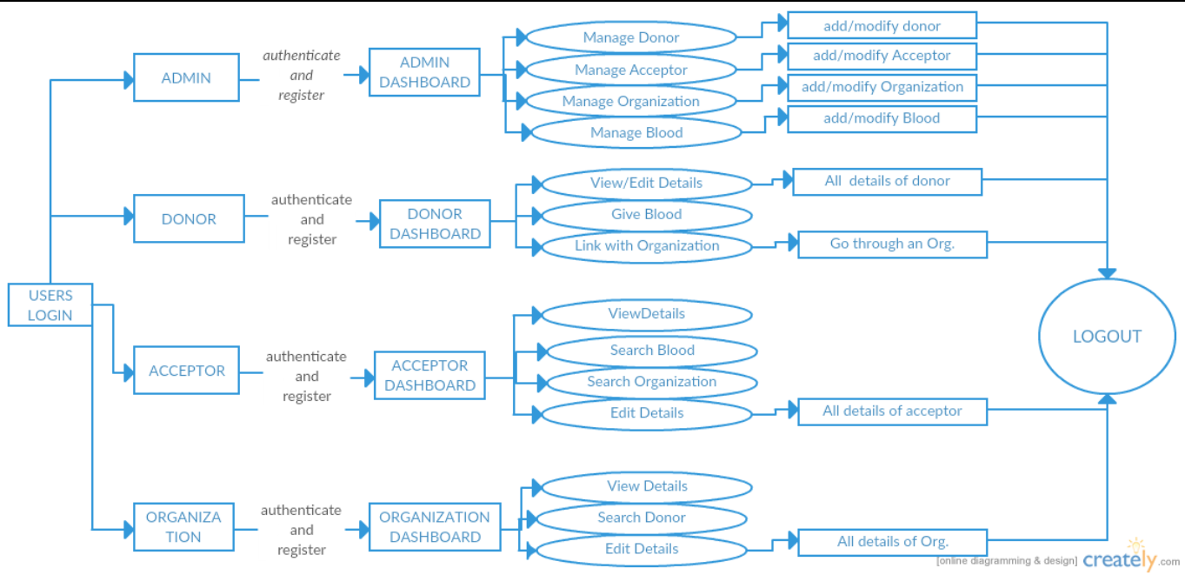

**9> ERD:= ENTITY RELATIONSHIP DIAGRAMS**

1. **ERD FOR USERS TO ADMIN**

Has

ADMIN

USERS

|  |
| --- |
| **Users** |
| ad_id |
| Ac_id |
| Do_id |
| Org_id |
| Ad_username |
| Ac_username |
| Do_username |
| Org_username |
| Ad_password |
| Ac_password |
| Do_password |
| Org_password |
| User_type |

|  |
| --- |
| **ADMIN** |
| Ad_id |
| Ad_firstname |
| Ad_lastname |

1. **ERD FOR USERS TO DONOR**

Has

DONOR

USERS

|  |
| --- |
| **USERS** |
| ad_id |
| Ac_id |
| Do_id |
| Org_id |
| Ad_username |
| Ac_username |
| Do_username |
| Org_username |
| Ad_password |
| Ac_password |
| Do_password |
| Org_password |
| User_type |

|  |
| --- |
| **DONOR** |
| Do_id |
| Do_salutation |
| Do_firstname |
| Do_middlename |
| Do_lastname |
| Do_dob |
| Do_age |
| Do_addressline1 |
| Do_ addressline2 |
| Do_city |
| Do_state |
| Do_country |
| Do_zipcode |
| Do_contatcno |
| Do_email |
| Do_sex |
| Do_weight |
| Do_bloodid |
| Do_bloodtype |
| Do_entrydate |
| Do_quantity |
| Do_status |
| Do_orgid |
| Do_orgname |
| Do_description |

1. **ERD FOR USERS TO ACCEPTOR**

Has

USERS

ACCEPTOR

|  |
| --- |
| **USERS** |
| ad_id |
| Ac_id |
| Do_id |
| Org_id |
| Ad_username |
| Ac_username |
| Do_username |
| Org_username |
| Ad_password |
| Ac_password |
| Do_password |
| Org_password |
| User_type |

|  |
| --- |
| **ACCEPTOR** |
| ac_id |
| ac_salutation |
| ac_firstname |
| ac_middlename |
| ac_lastname |
| ac_dob |
| ac_age |
| ac_addressline1 |
| ac_ addressline2 |
| ac_city |
| ac _state |
| ac _country |
| ac _zipcode |
| ac _contatcno |
| ac _email |
| ac _sex |
| ac_description |
| ac _bloodid |
| ac _bloodtype |
| ac _entrydate |
| ac _quantity |
| ac _status |
| ac _orgid |
| ac _orgname |
| Ac_doctorname |

1. **ERD FOR USERS TO ORGANIZATION**

Has

USERS

ORGANIZATION

|  |
| --- |
| **USERS** |
| ad_id |
| Ac_id |
| Do_id |
| Org_id |
| Ad_username |
| Ac_username |
| Do_username |
| Org_username |
| Ad_password |
| Ac_password |
| Do_password |
| Org_password |
| User_type |

|  |
| --- |
| **ORGANIZATION** |
| Org_id |
| Org_name |
| Org_addressline1 |
| Org_addressline2 |
| Org_city |
| Org_state |
| Org_country |
| Org_zip |
| Org_email |
| Org_ contactno |
| Org_bloodid |
| Org_bloodtype |
| Org_ quantity |
| Org_ description |
| Org_id |
| Org_name |
| Org_addressline1 |
| Org_addressline2 |
| Org_city |
| Org_state |
| Org_country |
| Org_zip |
| Org_email |
| Org_ contactno |
| Org_bloodid |
| Org_donorid |
| Org_acceptorid |

1. **ERD FOR ORGANIZATION TO DONOR**

Has

DONOR

ORGANIZATION

|  |
| --- |
| **ORGANIZATION** |
| Org_id |
| Org_name |
| Org_addressline1 |
| Org_addressline2 |
| Org_city |
| Org_state |
| Org_country |
| Org_zip |
| Org_email |
| Org_ contactno |
| Org_bloodid |
| Org_bloodtype |
| Org_ quantity |
| Org_donorid |
| Org_acceptorid |

|  |
| --- |
| **DONOR** |
| Do_id |
| Do_salutation |
| Do_firstname |
| Do_middlename |
| Do_lastname |
| Do_dob |
| Do_age |
| Do_addressline1 |
| Do_ addressline2 |
| Do_city |
| Do_state |
| Do_country |
| Do_zipcode |
| Do_contatcno |
| Do_email |
| Do_sex |
| Do_weight |
| Do_bloodid |
| Do_bloodtype |
| Do_entrydate |
| Do_quantity |
| Do_status |
| Do_orgid |
| Do_orgname |
| Do_description |

1. **ERD FOR ORGANIZATION TO ACCEPTOR**

Has

ACCEPTOR

ORGANIZATION

|  |
| --- |
| **ORGANIZATION** |
| Org_id |
| Org_name |
| Org_addressline1 |
| Org_addressline2 |
| Org_city |
| Org_state |
| Org_country |
| Org_zip |
| Org_email |
| Org_ contactno |
| Org_bloodid |
| Org_bloodtype |
| Org_ quantity |
| Org_donorid |
| Org_acceptorid |

|  |
| --- |
| **ACCEPTOR** |
| ac_id |
| ac_salutation |
| ac_firstname |
| ac_middlename |
| ac_lastname |
| ac_dob |
| ac_age |
| ac_addressline1 |
| ac_ addressline2 |
| ac_city |
| ac _state |
| ac _country |
| ac _zipcode |
| ac _contatcno |
| ac _email |
| ac _sex |
| ac_description |
| ac _bloodid |
| ac _bloodtype |
| ac _entrydate |
| ac _quantity |
| ac _status |
| ac _orgid |
| ac _orgname |
| Ac_doctorname |

1. **ERD FOR ORGANIZATION TO BLOOD**

Has

BLOOD

ORGANIZATION

|  |
| --- |
| **ORGANIZATION** |
| Org_id |
| Org_name |
| Org_addressline1 |
| Org_addressline2 |
| Org_city |
| Org_state |
| Org_country |
| Org_zip |
| Org_email |
| Org_ contactno |
| Org_bloodid |
| Org_bloodtype |
| Org_ quantity |
| Org_donorid |
| Org_acceptorid |

|  |
| --- |
| **BLOOD** |
| Blood_id |
| Blood_name |
| Blood_details |
| Blood_type |

1. **ERD FOR ACCEPTOR TO BLOOD**

Has

BLOOD

ACCEPTOR

|  |
| --- |
| **ACCEPTOR** |
| ac_id |
| ac_salutation |
| ac_firstname |
| ac_middlename |
| ac_lastname |
| ac_dob |
| ac_age |
| ac_addressline1 |
| ac_ addressline2 |
| ac_city |
| ac _state |
| ac _country |
| ac _zipcode |
| ac _contatcno |
| ac _email |
| ac _sex |
| ac_description |
| ac _bloodid |
| ac _bloodtype |
| ac _entrydate |
| ac _quantity |
| ac _status |
| ac _orgid |
| ac _orgname |
| Ac_doctorname |

|  |
| --- |
| **BLOOD** |
| Blood_id |
| Blood_name |
| Blood_details |
| Blood_type |

1. **ERD for ACCEPTOR TO ORGANIZATION**

Has

ORGANIZATION

ACCEPTOR

|  |
| --- |
| **ACCEPTOR** |
| ac_id |
| ac_salutation |
| ac_firstname |
| ac_middlename |
| ac_lastname |
| ac_dob |
| ac_age |
| ac_addressline1 |
| ac_ addressline2 |
| ac_city |
| ac _state |
| ac _country |
| ac _zipcode |
| ac _contatcno |
| ac _email |
| ac _sex |
| ac_description |
| ac _bloodid |
| ac _bloodtype |
| ac _entrydate |
| ac _quantity |
| ac _status |
| ac _orgid |
| ac _orgname |
| Ac_doctorname |

|  |
| --- |
| **ORGANIZATION** |
| Org_id |
| Org_name |
| Org_addressline1 |
| Org_addressline2 |
| Org_city |
| Org_state |
| Org_country |
| Org_zip |
| Org_email |
| Org_ contactno |
| Org_bloodid |
| Org_bloodtype |
| Org_ quantity |
| Org_ description |
| Org_id |
| Org_name |
| Org_addressline1 |
| Org_addressline2 |
| Org_city |
| Org_state |
| Org_country |
| Org_zip |
| Org_email |
| Org_ contactno |
| Org_bloodid |
| Org_donorid |
| Org_acceptorid |

1. **ERD FOR DONOR TO BLOOD**

Has

BLOOD

DONOR

|  |
| --- |
| **DONOR** |
| Do_id |
| Do_salutation |
| Do_firstname |
| Do_middlename |
| Do_lastname |
| Do_dob |
| Do_age |
| Do_addressline1 |
| Do_ addressline2 |
| Do_city |
| Do_state |
| Do_country |
| Do_zipcode |
| Do_contatcno |
| Do_email |
| Do_sex |
| Do_weight |
| Do_bloodid |
| Do_bloodtype |
| Do_entrydate |
| Do_quantity |
| Do_status |
| Do_orgid |
| Do_orgname |
| Do_description |

|  |
| --- |
| **BLOOD** |
| Blood_id |
| Blood_name |
| Blood_details |
| Blood_type |

1. **ERD for DONOR TO ORGANIZATION**

Has

ORGANIZATION

DONOR

|  |
| --- |
| **DONOR** |
| Do_id |
| Do_salutation |
| Do_firstname |
| Do_middlename |
| Do_lastname |
| Do_dob |
| Do_age |
| Do_addressline1 |
| Do_ addressline2 |
| Do_city |
| Do_state |
| Do_country |
| Do_zipcode |
| Do_contatcno |
| Do_email |
| Do_sex |
| Do_weight |
| Do_bloodid |
| Do_bloodtype |
| Do_entrydate |
| Do_quantity |
| Do_status |
| Do_orgid |
| Do_orgname |
| Do_description |

|  |
| --- |
| **ORGANIZATION** |
| Org_id |
| Org_name |
| Org_addressline1 |
| Org_addressline2 |
| Org_city |
| Org_state |
| Org_country |
| Org_zip |
| Org_email |
| Org_ contactno |
| Org_bloodid |
| Org_bloodtype |
| Org_ quantity |
| Org_ description |
| Org_id |
| Org_name |
| Org_addressline1 |
| Org_addressline2 |
| Org_city |
| Org_state |
| Org_country |
| Org_zip |
| Org_email |
| Org_ contactno |
| Org_bloodid |
| Org_donorid |
| Org_acceptorid |

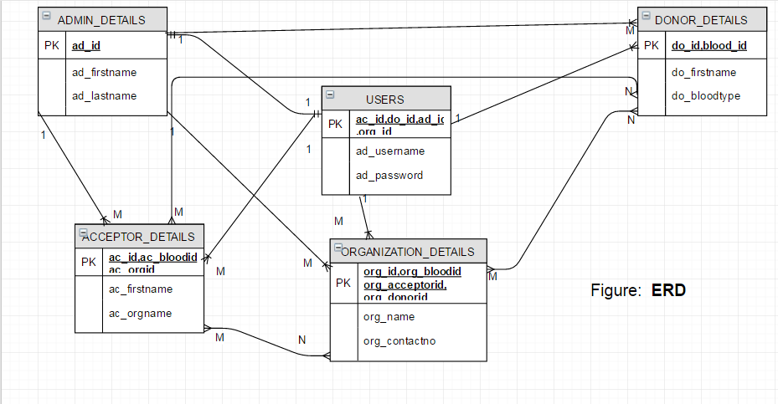

**10>CLASS DIAGRAM :=**

**CLASS DIAGRAM**

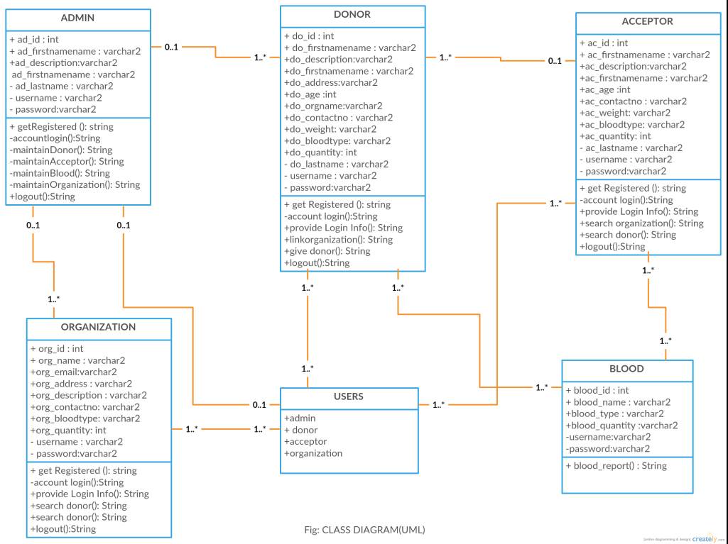

**11> USE CASE DIAGRAM :=**

**USE-CASE DIAGRAMS**

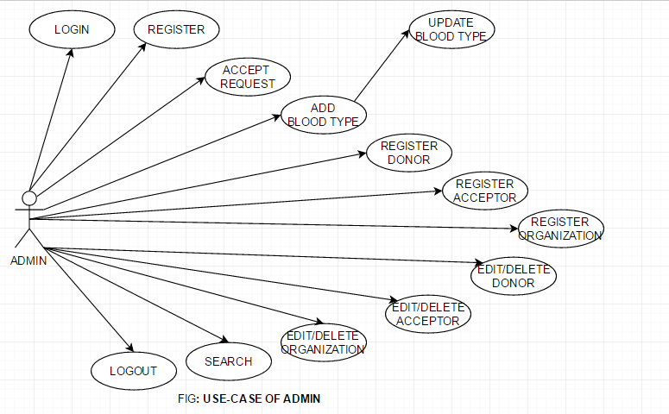

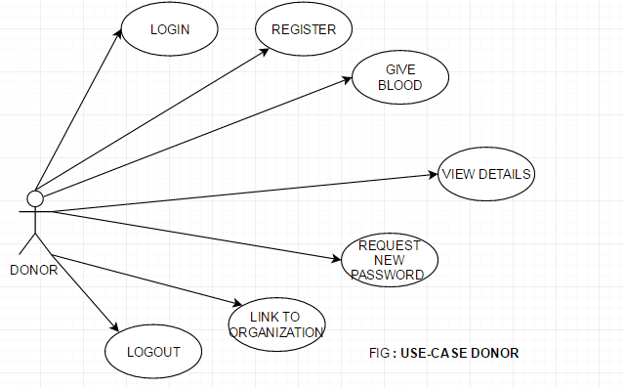

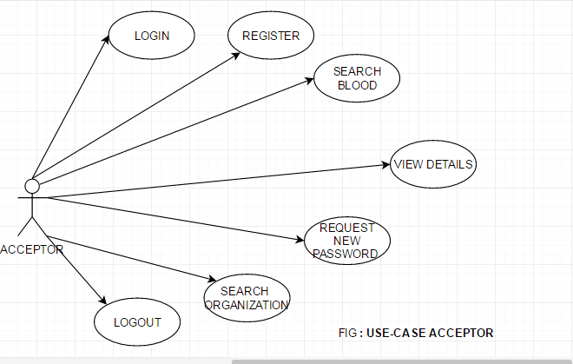

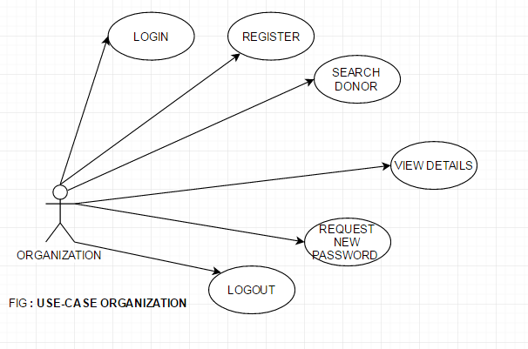

|  |  |
| --- | --- |
| **Use Case Name** | Login |
| Participating Actors | Admin, donor, acceptor, organization |
| Flow Of events | The actor will give username and password to the system .the system will authenticate and verify it. |
| Entry Condition | The actor will enter the system by using username and password |
| Exit Condition | If unauthenticated then should be exited. |
| Quality Requirement | Password must satisfy the complexity of the requirement. |

|  |  |
| --- | --- |
| **Use Case Name** | Admin Registration |
| Participating Actors | Admin |
| Flow Of events | The admin will give all the details and submit . |
| Entry Condition | Must satisfy all the norms of the loginin |
| Exit Condition | Successful or unsuccessful completion of account |
| Quality Requirement | All fields are mandatory |

|  |  |
| --- | --- |
| **Use Case Name** | Donor Registration |
| Participating Actors | Donor |
| Flow Of events | The donor must enter all personal details and submit . |
| Entry Condition | View Home Page |
| Exit Condition | Registered donor should be successfully logged out .Error message must be displayed on unsuccessful creation. |
| Quality Requirement | Best error handling techniques . Check on mandatory fields. |

|  |  |
| --- | --- |
| **Use Case Name** | Acceptor Registration |
| Participating Actors | Acceptor |
| Flow Of events | The acceptor must provide all personal details and submit . |
| Entry Condition | View Home Page |
| Exit Condition | Registered acceptor should be successfully logged out .Error message must be displayed on unsuccessful creation. |
| Quality Requirement | Best error handling techniques . Check on mandatory fields. |

|  |  |
| --- | --- |
| **Use Case Name** | Organization Registration |
| Participating Actors | Organization |
| Flow Of events | The organization must provide all personal details and submit . |
| Entry Condition | View Home Page |
| Exit Condition | Registered organization should be successfully logged out .Error message must be displayed on unsuccessful creation. |
| Quality Requirement | Best error handling techniques . Check on mandatory fields. |

**12> TECHNOLOGY USED:=**

JSP,JAVA ,CSS,HTML,MYSQL and any other used as per required further.